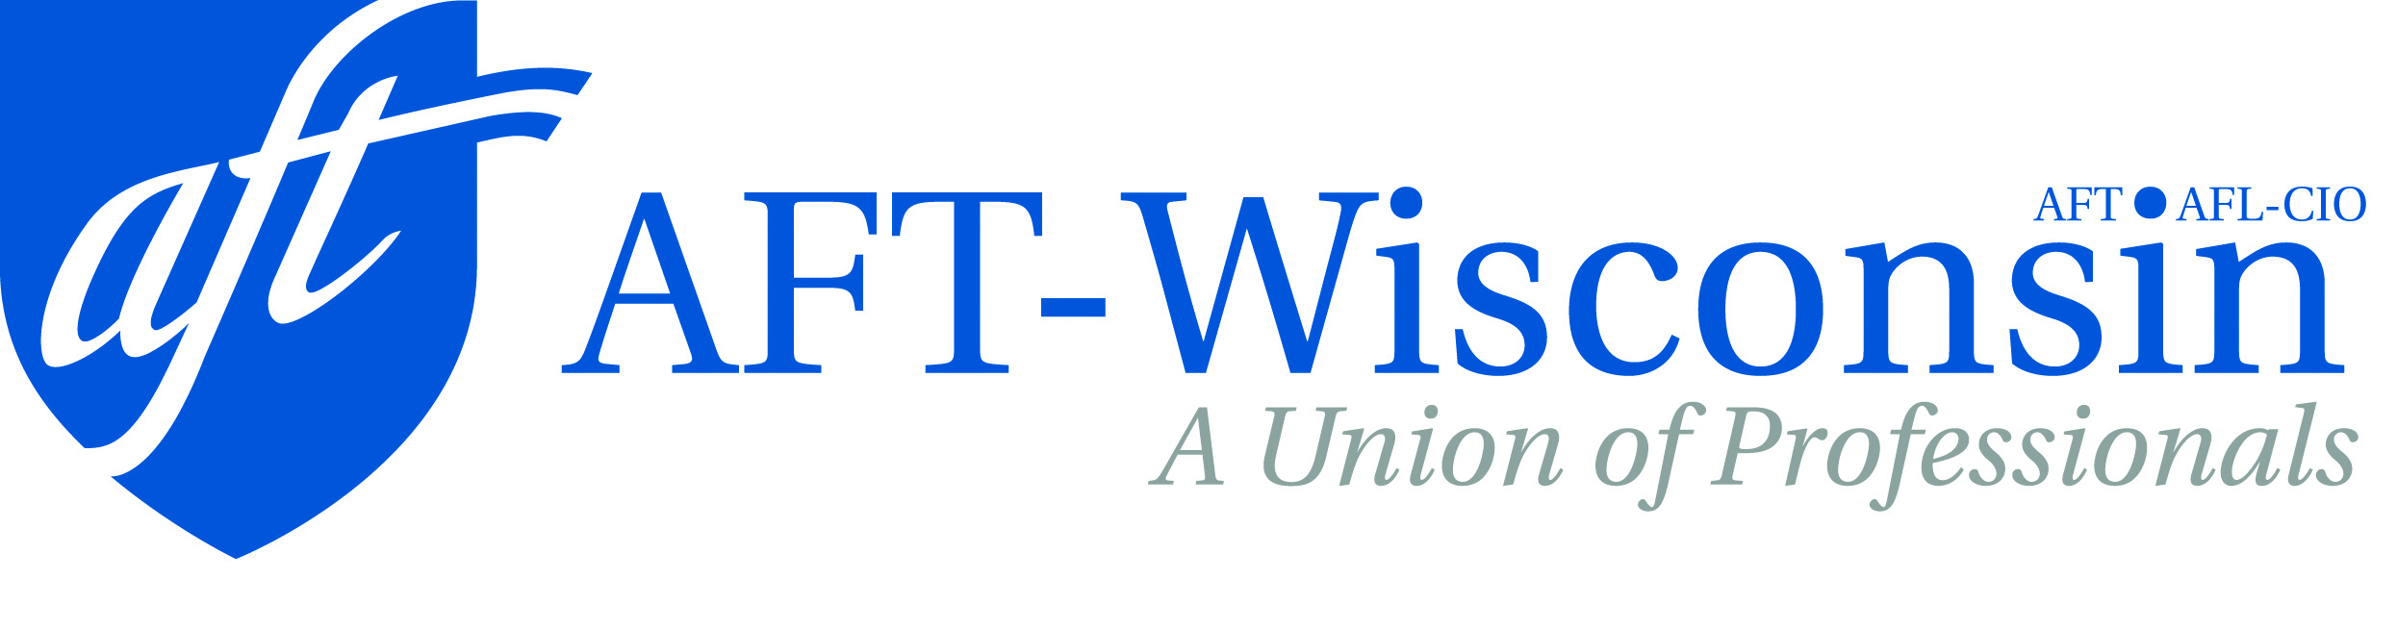
Field Organizer
Covering turf in the Milwaukee and Fox Valley area
Organizer must live in assigned area

Application Deadline: September 30th, 2023

Job Description:
AFT-Wisconsin is a labor organization comprised of members in the state PK-12 school system, the Wisconsin Technical College System, numerous state agencies, and the University of Wisconsin System. Field Organizer will work with members, potential members and coalition partners on internal/external organizing in order to build capacity and issue campaigns.
Primary Responsibilities:
- Recruit new members to the union
- Communicate with membership and potential member through home visits, worksite visits, emails, phone call, text messages, and digital platforms.
- Implement organizing strategy and help develop campaign plans
- Manage access to all relevant documents and union communication to ensure that member information is kept private and secure
- Build political activism with membership through collaboration with local coalition partners and help local unions recruit members and non-members for days of action with these coalition partners
- Plan, coordinate and attend event and direct actions
- Other duties as assigned

Preferred Qualifications:
- Experience with grassroots organizing experience (external union organizing preferred), including membership building, leadership development, and home visits
- Commitment to the labor movement and to AFT-Wisconsin
- General knowledge of education and labor issues
- General knowledge of Wisconsin’s political process and state-specific political issues
- Ability to work with union members across a variety of employment sectors
- Demonstrated ability to write and speak effectively
- Ability to listen actively and frame issues
- Willingness to work long and irregular hours, including weekends
- Must be in possession of an insured vehicle and valid driver’s license
- Must be able to provide proof of vaccination for Covid-19
- College degree preferred

Salary and Benefits:
$40,800 annual salary and strong benefit package, under collective bargaining agreement.
Send Cover Letter and Resume to:
Kim Kohlhaas, President
president@aft-wisconsin.org

Review of applications will begin immediately.

AFT-Wisconsin is an equal opportunity employer and strongly encourages applications from people of color, persons with disabilities, women, and LGBT applicants.

